Project Design Phase-II

Technology Stack (Architecture & Stack)
Date | 18 June 2026
Team ID
Project Name | ShopEZ
Maximum Marks | 4 Marks

Technical Architecture:
The deliverable shall include the architectural diagram as below and the information as per table 1 & table 2.
Example: ShopEZ — MERN E-commerce platform architecture

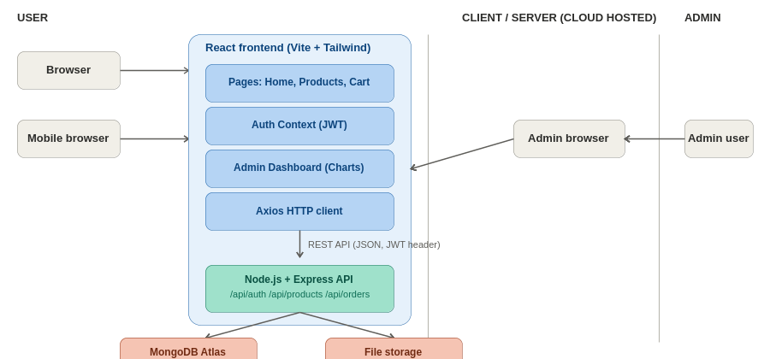
Figure 1: ShopEZ technical architecture

Table-1 : Components & Technologies:
S.No | Component | Description | Technology
1. | User Interface | How the user interacts with the application — web UI for browsing, cart, checkout, and admin dashboard. | React 18, Tailwind CSS v4, Framer Motion, Lucide React, react-hot-toast
2. | Application Logic-1 | Frontend routing, page navigation, and state management. | React Router v6, Context API
3. | Application Logic-2 | Backend business logic for authentication, products, cart, and order processing. | Node.js, Express.js
4. | Application Logic-3 | Admin analytics computation (revenue, order stats, charts). | Chart.js / react-chartjs-2
5. | Database | Data type, configurations, schema for Users, Products, Orders. | MongoDB, Mongoose
6. | Cloud Database | Database service on cloud. | MongoDB Atlas
7. | File Storage | File storage for product images uploaded by admins. | Local filesystem — client/public/uploads (via Multer)
8. | External API-1 | HTTP requests from frontend to backend REST API. | Axios
9. | External API-2 | Authentication & authorization between frontend and backend. | JWT (jsonwebtoken)
10. | Security Library | Password hashing for user accounts. | bcryptjs

Table-2: Application Characteristics:
S.No | Characteristics | Description | Technology
1. | Open-Source Frameworks | Open-source frameworks used for building the frontend and backend of ShopEZ. | React, Vite, Tailwind CSS, Express.js, Mongoose, Framer Motion
2. | Security Implementations | Security and access controls implemented for authentication and data protection. | JWT-based authentication, bcryptjs password hashing, role-based access control (USER/ADMIN), protected admin routes
3. | Scalable Architecture | Justifies scalability of the architecture using a layered (3-tier) design separating frontend, backend API, and database. | 3-tier architecture: React frontend, Express REST API, MongoDB database
4. | Availability | Ensures the application remains available via cloud-hosted database and stateless REST API that can run on multiple server instances. | MongoDB Atlas (managed, replicated database), Node.js/Express server
5. | Performance | Design considerations for performance, including efficient queries and fast frontend builds. | MongoDB indexes on category/gender fields, Vite for fast builds, Axios caching, lazy-loaded images

